**Appendix 3 User Guide**

**User Manual - Java Program Clinical Management System**

**Content**

Understand the program

Using the program

Examples

**Understand the program**

The program is meant to be used for adding and storing patient, employee data to a database by means of a GUI system.

All the entered data will be stored on a local database and the information can be retrieved by using the GUI.

The users of this software have the option to add, remove, search and edit the data they wish to handle.

**Using the program**

Running the program through the IDE will start the application.

This is the main window. From here the user can accsess different genres and see a list of movies available.

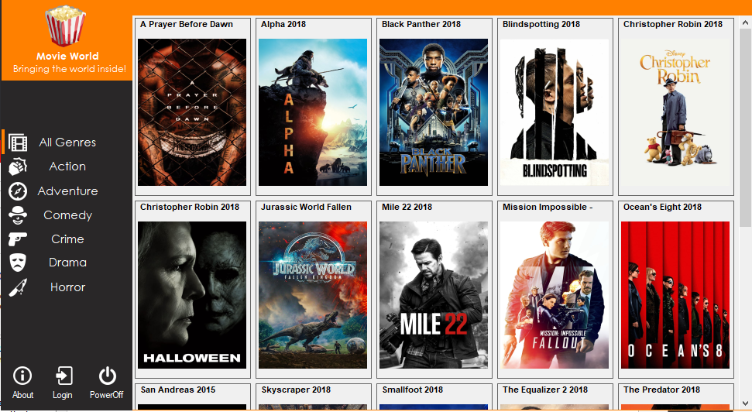

Figure 1. Main window

This is the Action genres section. Here we have a list of movies dedicated to Action

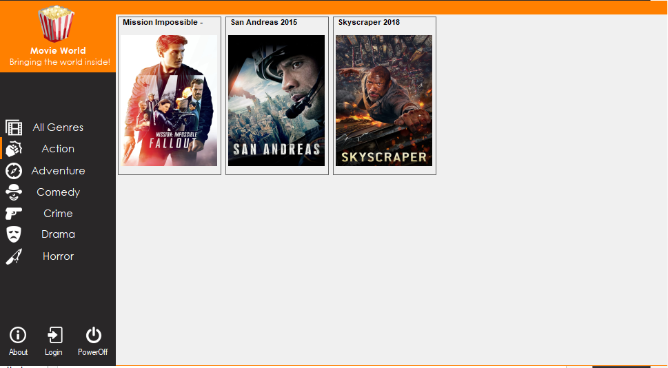

Figure 2. Action genre page

When the user decides on the moie he/she would like to view, they click it and a new pop-up window appears.

Here we have selected the movie “Skyscraper”, it has a short description of the movie below the title. From this point the user can either book a ticket to watch the movie or watch it online.

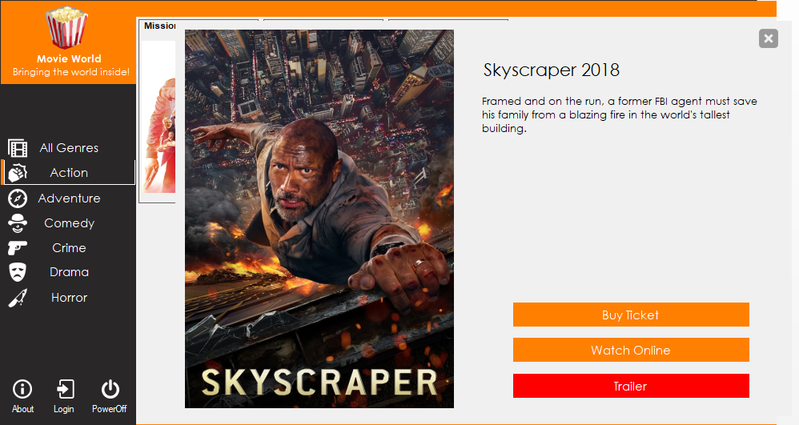

Figure 3. Movie description

If the user chooses to buy a ticket, after the “Buy ticket” bar is pressed, a pop-up window will appear conserning details relevant to buy a ticket.

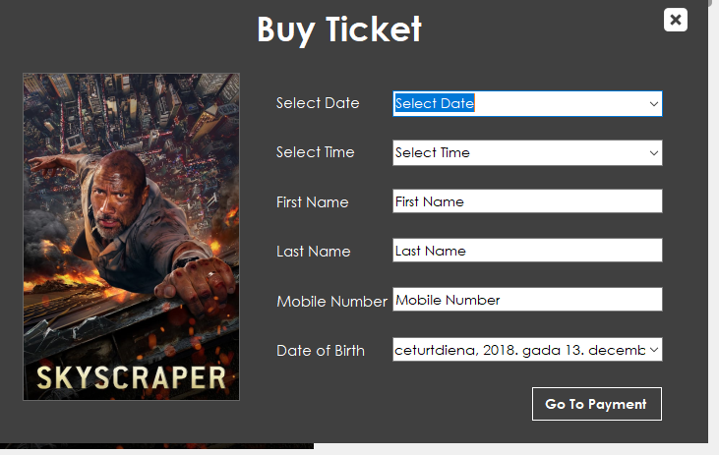

When the admin wants to add a movie a pop-window will appear after add movie bar is pressed, then the admin has to fill out the form providing the movie info.

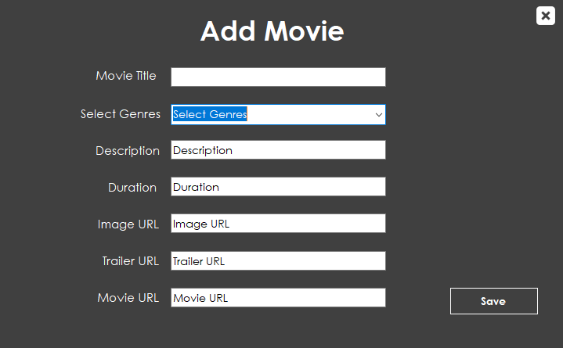

Here is a subscribe form that will shows when the user wants to subscribe.

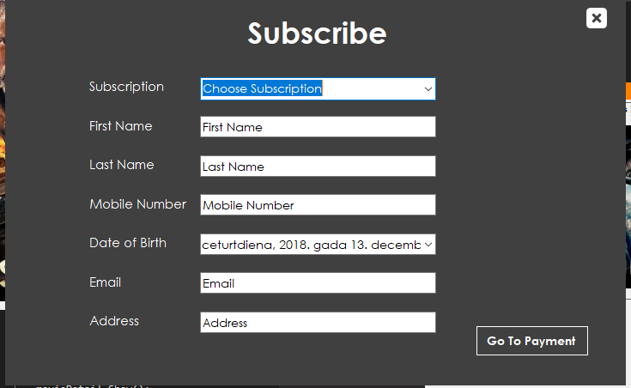

This is the remove movie session action from here the Admin can selects the movie that he wants to remove with its genre. And delete it

